Rollerball - Project 03

Design Document

Team Name : stringCheese

Team Members :

Chris Schaffer, Meetkumar Savaliya, Tim Stroup, Wei Chen, Ya-Hsin Cheng (List alphabetically)

Class Diagram :

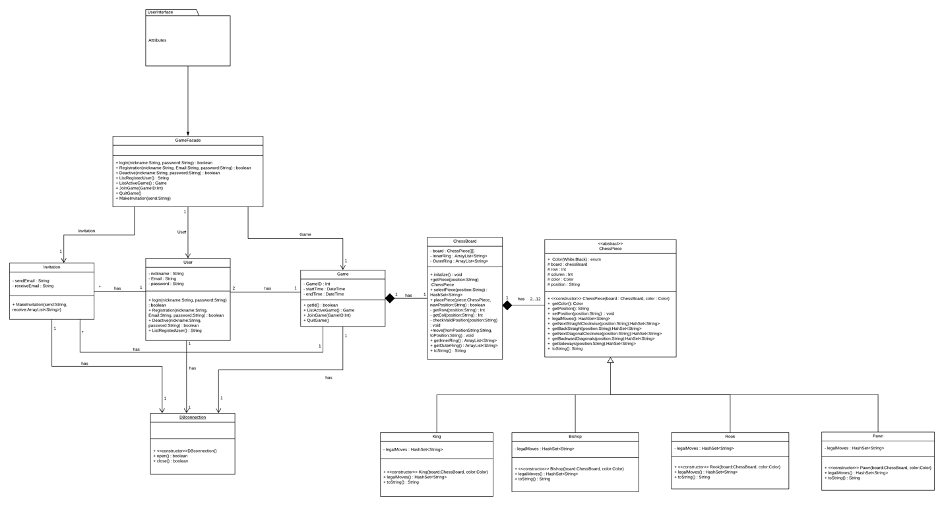

Sequence Diagrams :

* Take Turn

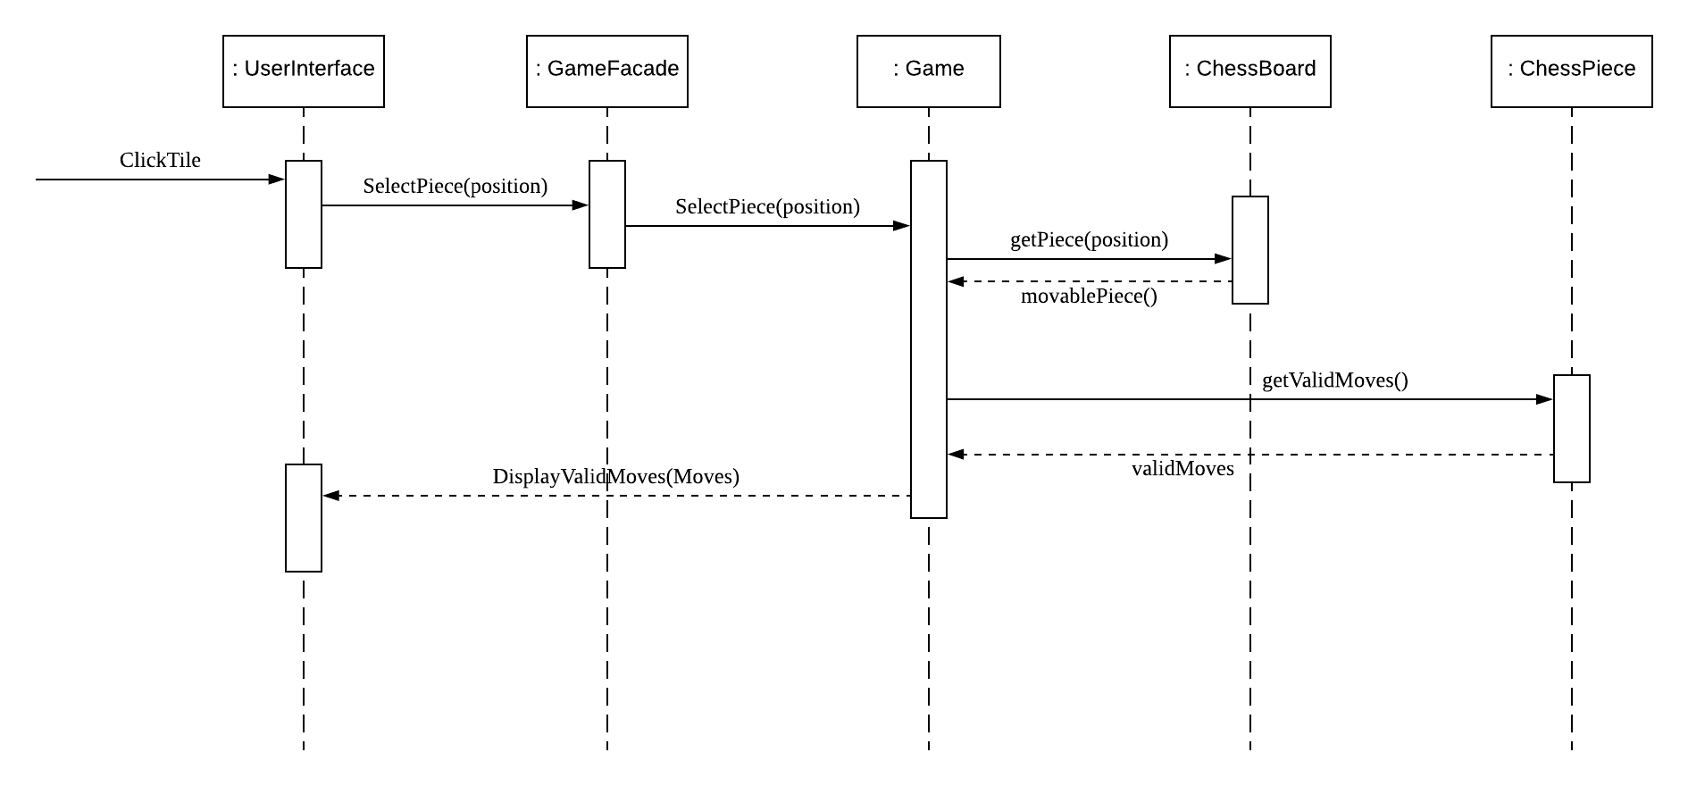

* Join Game

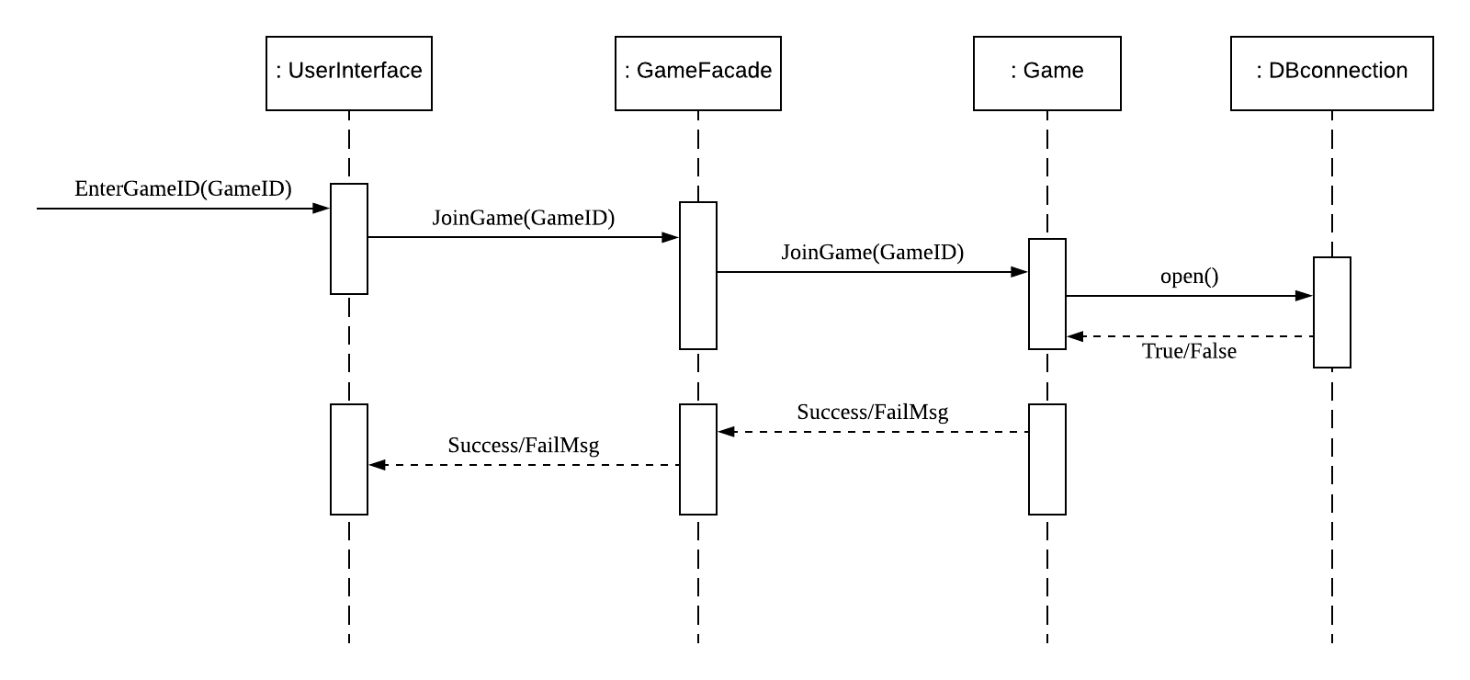

* Send Invitation

